javascript:if((/\/login\.html/i).test(window.location.href) != true){ window.location.href = '/admin.html'; } else { $("#loginElement").val('sam77');$("[name='password_supplied']").val('Panasonic2');$("#submitButton").click(); }

javascript:if((/\/login\.html/i).test(window.location.href) != true){ window.location.href = '/admin.html'; } else { $("#loginElement").val('hotel');$("[name='password_supplied']").val('H0te1@sdl91');$("#submitButton").click(); }

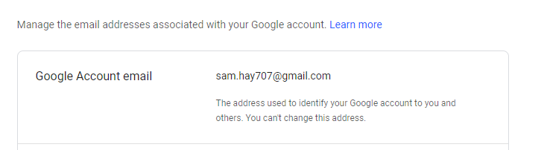

<https://www.levart.com.au/salesinfo>

<https://www.reserve.unilodge.com.au/>

<https://levart.aceproject.com/>

<https://www.lessannoyingcrm.com/app/Workspace>

<https://www.admin.levartds.com/adminChannelControlTinderbox.html>

<https://www.admin.levartds.com/adminSiteList.html>

<https://calendar.google.com/calendar/r?mode=day&date=20180827T062349>

<https://notes.levart.com.au/wiki/Main_Page>

<https://www.levart.com.au/salesinfo>

<https://help.levart.com.au/pages/viewpage.action?spaceKey=LEV&title=Levart+Knowledge+Base+Home>

<https://www.fcgphotelhub.com/Login.aspx?ReturnUrl=%2f>

<https://app.rmscloud.com/Login>

<https://www.smartbooking.co.nz/login.html>.